List of relevant documents

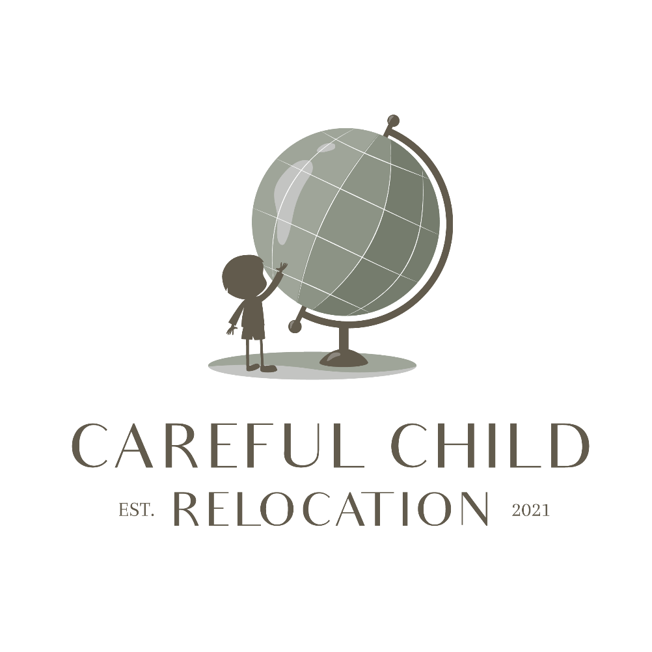
- Births certificates
- Marriage certificate
- Divorce: court decision, proof or registration
- Divorce covenant
- Parenting plan
- Proof of official addresses of the parents and the children
- Proof of the date of relocation
- Proof of habitual residence
- Proof of permission / agreement
- Proof of acquiescence

To proof what country is the habitual residence, you can think of the following subjects:
- on what address is the child registered officially?
- on what address is the child registered at a family doctor/ dentist etc.?
- where does the child attend school/ daycare?
- is the child receiving special education that makes the child extra attached to the school?
- where does the child have most family living nearby?
- where does the child have friends living nearby?
- where does the child know his/her way around the neighborhood?
- where is the child attached to amenities in the neighborhood (parks, museums, etc.)?

In what way evidence can or must be presented depends on national procedural law.
Generally speaking, when providing evidence one can think of:
- documents concerning the address
- sale, buy or rental agreements concerning a house and/or car
- employment contracts
- flight data
- memberships
- bank statements
- what-app conversations
- emails
- screenshots from school parent portals, etc.
- (written) statements from third parties
- audio recordings and transcripts thereof
- (family) photographs.

